**Instrumental Conditioning 2 (Module)**

**Module: Generalization and Discrimination**

**Subtopic: The Discriminative Stimulus  
-** Sdelta is a cue which indicates when the contingent relationship is not valid  
-SD indicated when the response indicated that there is a contingency

**Subtopic: Generalization**-will respond to cues that are similar (red light🡪any other colour light)

**Subtopic: Discrimination and Extinction  
-**stops getting rewarded, behaviour goes unnoticed, stops performing good behaviour  
-discrimination: reserves good behaviour to only a certain person/people  
-response is voluntary in instrumental conditioning

**Module: Continuous vs. Partial reinforcement**

**Subtopic: Continuous vs. Partial Reinforcement  
-Ratio Schedule:** based on the number of responses made by subjects, which determine when reinforcement is given (Fr-1 schedule rewarded with food for ach pecking response; FR-10 schedule is rewarded with food for every 10th pecking response)  
-**Interval Schedule:** based on the time since the last response that was reinforced (pigeon on a FI 1 minute schedule is rewarded with food for the first pecking response after a 1 minute period, potential to earn 60 food pellets; FI 10 is rewarded with food for the first pecking response after a 10minute period- can get the max of 6 pellets

**Subtopic: Fixed vs. Variable  
-Fixed:** number of responses made on a ratio schedule or the period of time elapsed on an interval schedule is fixed-**Variable:** number of responses made on a ratio schedule or the period of time elapsed on an interval schedule is made variable

**Subtopic: Fixed Ratio  
--**reinforcement is delivered at a set number **-**ex: paid set amount of money for every three suits sewed, effectively placing worker on a FR3 schedule  
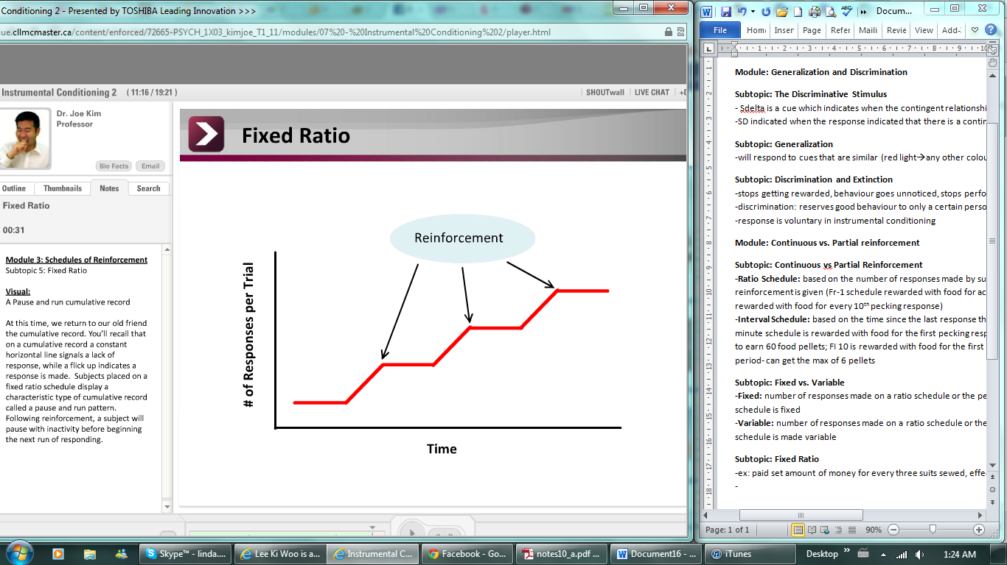

**Subtopic: Variable Ratio  
-**reinforcement is delivered after some random number of responses around a characteristic mean  
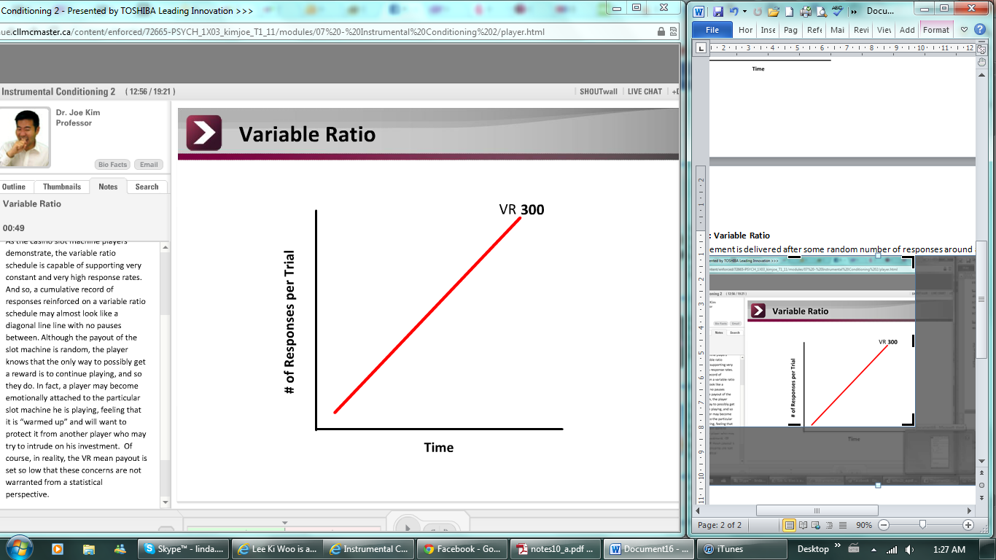 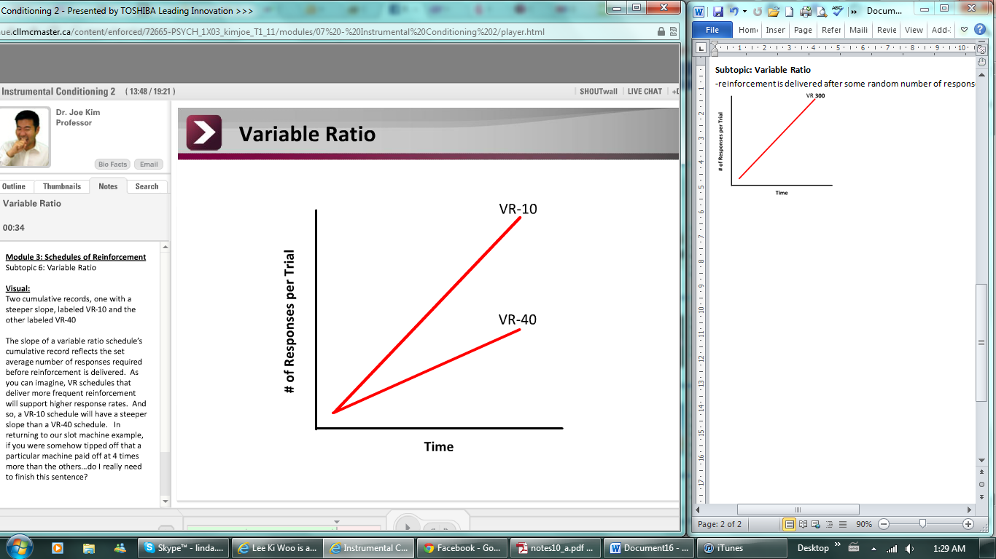  
**Subtopic: Fixed Interval  
-**reinforcement is delivered following the first response after a set interval of time  
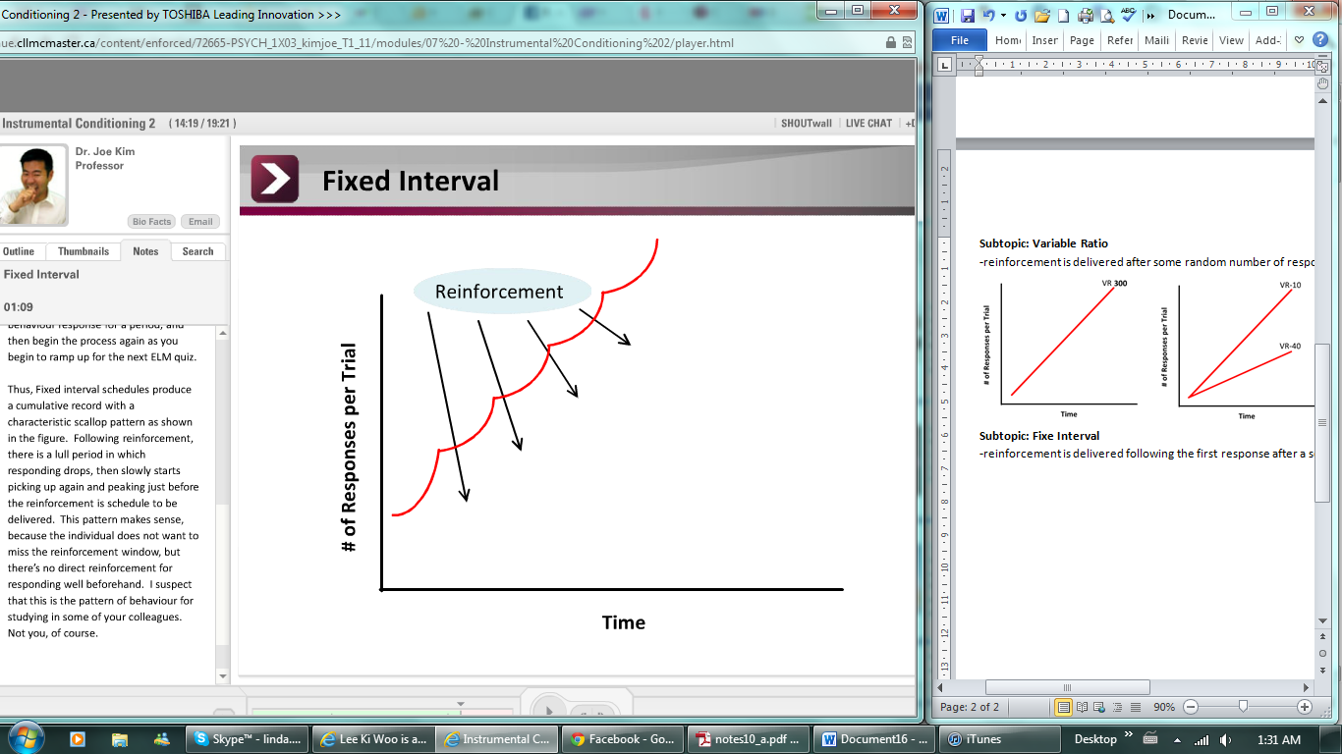  
**Subtopic: Variable Interval  
-**reinforcement is delievered followibg the first response after a variable interval of time, around a characteristic mean

**Subtopic: Extinction and Schedules  
-**partial reinforcement schedules are far more robust than those trained on a continuous reinforcement schedule  
-thus PRF learned behaviours are more resistant to extincstion than are CRP learned behaviours